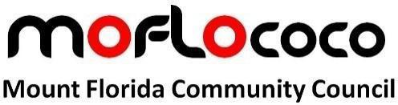

Tuesday 25th November 2025 at 7pm

Everyone in the Mount Florida area is welcome to attend.

In-person meetings held at the Clincarthill Parish Church of Scotland at 7pm.

Agenda.
- Welcome
- Note attendance, apologies.
- Approve minutes of last meeting
- Matters arising from last meeting
- Summary of correspondence
- Treasurer’s report
- Ward Councillor’s report
- Police report
- Business Breakfast
- Letherby update
- Any other business
- Close

Ward Councillor rota:

Nov 2025 Holly Bruce

Dec 2025 No meeting

Jan 2026 Paul Leinster

From the constitution:
The objectives of the Community Council shall be to:
Seek to develop a Local Vision e.g., a mission statement (see Guidance clause 1.1);
Gather and articulate the views of the community which it represents;
Express fairly the views, diversity of opinions and outlooks of the community to Glasgow City Council; and other public/private organisations;
Act as a voice for their local area on any matters affecting their community’s lives, welfare and environment;
Liaise with other community groups within their local area;
Take any such action in the interests of the community as appears to be practicable;
Promote the well-being of the community and to foster community spirit.

