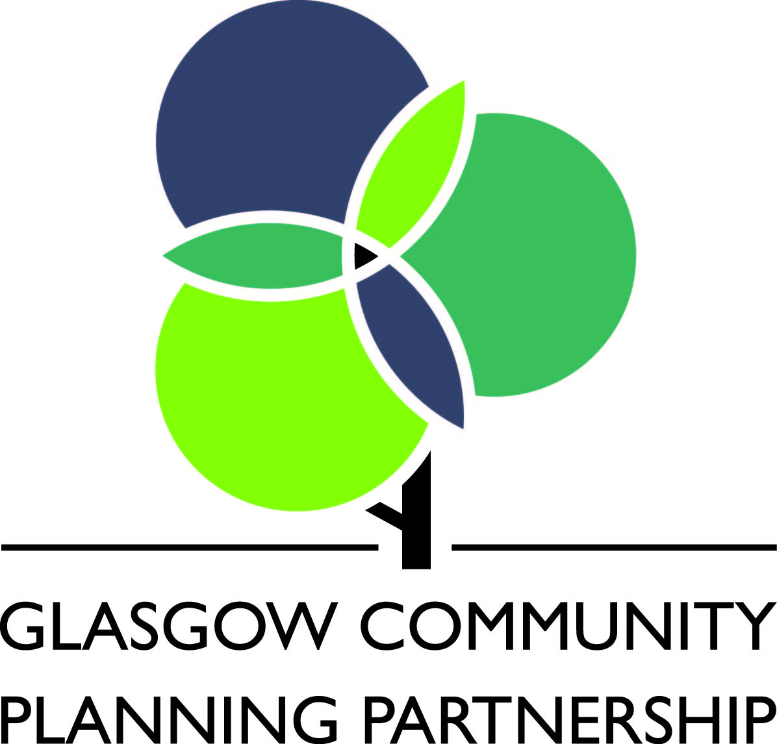
Glasgow City Council

GUIDANCE NOTES FOR COMPLETING COMMUNITY BUDGETING PROPOSAL FORM 2016/17

It is essential that you read these guidance notes carefully before filling out your Funding Proposal Form.

Below, you will find general information on Community Budgeting, including how to apply and examples of proposals that can be supported. The section entitled Completing your Funding Proposal Form provides guidance on how to answer each of the questions in the form.

Where possible the Funding Proposal Form should be completed electronically.

- Purpose of Community Budgeting - to provide funding for projects or services that:-

  - are determined locally and benefit a specific area or community;
  - the Council or other agencies are not obliged to provide; and
  - help to address the Area Partnerships Investment Priorities.

Who can apply?

  - Community and voluntary organisations that are based in Glasgow and have full control over their proposal are able to apply. Organisations should:-

    - be not-for-profit and should not allow anyone to profit from being associated with the organisation;
    - have a Managing Body, management committee (or similar body) which meets regularly;
    - have elected office bearers e.g. chairperson, secretary and treasurer;
    - have a Governing Document (e.g. a constitution) that has been approved by the organisation and signed by an office bearer; and
    - have a bank account with at least 2 unrelated signatories.

  - Public sector organisations will also be eligible to submit funding applications for Community Budgeting where they have demonstrated;
- Fit with local priorities;
- Involvement of local communities; and
- Additionality to core remits.

Community Budgeting grants should not be used to replace funding for services or activities that has been withdrawn by the Council or by another funder.

What can and cannot be supported.

  - Community Budgeting bids should focus on one or more of the local Area Partnership Investment Priorities: (please refer to section 6 of the application form)

Please Note - Proposals that do not fit with the investment priorities but that make a strong case for consideration can be considered if they:

      - Demonstrate a fit with the wider Council, Glasgow Community Planning Partnership or Glasgow’s Single Outcome Agreement priorities;

      - Demonstrate clearly:
- a response to an identified need within the local community;
- that it has involved the local community in its development; and
- will benefit the local community;

      - Provide a response to new or emerging issues (which had not previously been identified as an investment priority); and

      - Respond to “exceptional circumstances”.

  - Based on C.1, Community Budgeting can fund a wide variety of developmental projects. For example, projects that promote community activity, short-term/pilot projects (including staff costs), provide new equipment/materials for local organisations, activity costs at residential centres, environmental improvements, production of educational plays/materials, hire professional instructors, start-up grants or bus hire for day trips.

  - What Community Budgeting CANNOT fund:

As outlined in C.1, Community Budgeting should not be used for proposals that are not targeted at local priorities and do not make a strong case for consideration. In addition, there are types of proposals for which the Community Budgeting fund should not be used, as follows:
- Proposals for Ongoing Project/Service Running costs;
- Proposals for Activities that conflict with the policies of Glasgow City Council;
- Proposals for Statutory provision;
- Proposals for Retrospective funding;
- Proposals that would be more appropriately funded from other source(s);

  - If you are still unsure if your proposal is eligible, contact a member of the team on 0141 276 9880.

  - Applicants are expected, but not required, to make a contribution towards the cost of their proposal and this can be in cash or 'in kind' (eg. materials, transport, staff time spent on this proposal that is additional to normal hours). There is no standard contribution expected, however, contributions should reflect the size of your organisation, its usual income and the amount requested.

How are proposals evaluated?

D.1 Prior to the Community Budgeting Event, the relevant officer will assess the proposal’s eligibility against the criteria outlined in Sections B1, B2, C1 and C3. On occasions, the officer may request an external assessment of the impact and risk of the proposal e.g. to identify how the proposal and/or work of the organisation complements existing provision or addresses gaps in provision.

How to apply.

  - You are advised to submit your proposal to patricia.mcmahon2@glasgow.gov.uk or If submitting a paper copy, please return to the following address:

South Partnership & Development Team
The Adelphi Centre, Rm 15, 12 Commercial Road
Glasgow G5 0PQ Tel: 0141 276 9880

  - The Funding Proposal Form must be completed as fully and accurately as possible to avoid any delay in processing and assessing your proposal. Proposals that have not been fully completed may be returned. You will be asked to provide written quotations for equipment/services costing over £1,000 that you intend to purchase.

  - Proposals will be considered at the relevant Community Budgeting event.
- Please note that someone from your group/organisation will be required to attend in order to present your bid to the local community who will then vote for their preferred projects accordingly - this can be done as a verbal presentation , a short powerpoint/film presentation or stall/display boards (upto 4 mins long and facilities will be provided)

  - Your Funding Proposal Form must be signed and dated by an Office Bearer of your organisation (e.g. the chairperson, treasurer, secretary, etc). Please note that giving false or misleading information could result in the Council withdrawing any grant awarded and reclaiming any payments made to the organisation.

  - Completed Funding Proposal Forms should be submitted directly to Patricia McMahon at patricia.mcmahon2@glasgow.gov.uk, by the specified deadline.

  - Receipt of your completed Funding Proposal Form will be acknowledged within 3 working days.

  - Grants will normally be paid in one instalment. The grant will normally be released when the organisation signs and returns the formal offer, agreeing to meet all conditions, and can demonstrate a need for payment to be released. Please note that an Office Bearer will be required to attend the Community Budgeting event to sign the Grant Declaration Form and confirm the bank details on the application form.

Completing your Funding Proposal Form

Please note that the boxes will expand to provide an adequate amount of space to insert information, but size restrictions have been applied. We would therefore request that you provide your information concisely. When you click on a box, a cross will automatically be inserted or removed. If you require more space to answer any question, you should use continuation sheets (A4) and ensure that they are clearly marked with the section to which they refer.

INFORMATION ON YOUR ORGANISATION

Q1 Name and Contact Details of Organisation Applying for Funding: Provide all of the details requested in the form. These should be the main contact details of your organisation.
Q2 Name and Details for the Contact Person for the Proposal: Provide all of the details requested in the form. Please note, this person should be the person in your organisation that is able to provide additional information or respond to specific questions, where appropriate, in relation to your Funding Proposal Form.
Q3 Type of Organisation: Please tick the most appropriate box for your organisation and include a Charity Registration Number and/or a Care Inspectorate Registration Number, if applicable.
Q4 Main Aims and Activities of the Organisation: Tell us why your organisation was established in the first place and what it hopes to achieve. Please provide details on the activities that the organisation currently provides, e.g. if your organisation is a youth club, please tell us when young people attend the club, providing details of the times and days of the week.

INFORMATION ON YOUR FUNDING PROPOSAL

Q5 Title of the Funding Proposal: Please give your proposal an appropriate title that clearly describes the proposal and can distinguish the proposal from other grant awards that the organisation may have received in the past or may receive in the future, e.g. “Training Programme 2016” or “New Equipment 2016”.
Q6 Which of the Area Partnership Investment Priorities does it address? Please read Section C.1 (above)
Q7 Proposal Description: The description should include details on:
    - why you think the proposal is needed, including any evidence that indicates demand for the proposal;
    - how the local community has been involved in the development of this proposal;
    - what the funding will be used for i.e. what you intend to do, when it will happen, where it will take place and which other organisation(s) would be involved, if applicable;
    - how local people will benefit from the proposal; and
    - whether it links with one or more of the key objectives of Glasgow City Council, which are:
      - improving the efficiency and effectiveness of our services;
      - increasing access to lifelong learning;
      - making Glasgow a cleaner, safer city;
      - building a prosperous city;
      - improving health and wellbeing;

Q8 Additional to Core Remits: (Question for Public Sector Organisations Only) Please explain how the activity/service(s) for which funding has been requested is additional or different to what your organisation already provides, or should provide.

FINANCIAL INFORMATION

Q9 Please provide the amount requested.

Q10 Please provide the amount of match funding that will be used to deliver the proposal, in addition to the funding requested. This should include funding already approved and funding requested where you are waiting for a decision to be made as well any contribution your organisation is able to make.
Q11 Please provide the Total Cost of the proposal. This should equal the sum of the amounts provided for Q9 and Q10.
Q12 Other Secured Proposal Funding: If an amount of funding has been included under Q10, use the space provided to tell us about any other grant funding that will be used to deliver your proposal, including grants already approved and grant bids where you are waiting for a decision to be made and any contribution your organisation will be making.
Q13 Expenditure Breakdown: Please provide an itemised breakdown of the total expenditure (figure in Q11) to be incurred on this proposal. This is required as there may be some items/activities that we can’t fund. Please note that you will be required to provide quotes for individual items that costed over £1000. The total entered at the bottom of Question 13 should be the same as the figure entered in Question 11.

GOVERNANCE INFORMATION

Q14 Bank Account Details: Account Signatories - Please enter the names of the signatories and the positions they hold (for example, chairperson, treasurer, secretary). Your organisation will need to have at least 2 signatories to withdraw money, and none of the signatories can be related. Your Funding Proposal Form cannot be processed if your organisation does not meet these requirements.
Use the spaces provided to give the required details for all bank accounts held by your organisation.
Q15 Protecting Vulnerable Groups Scheme: On 28th February 2011, the Scottish Government introduced a new membership scheme to replace and improve upon the current disclosure arrangements for people who work with vulnerable groups. Under most circumstances, staff and/or volunteers working with children and young people will need to be registered with the Protecting Vulnerable Groups Scheme (PVG) to ensure they are not on the list of people excluded from such activities. Your organisation may be committing an offence if it offers childcare work (paid or unpaid) to someone who is on this list, so it is important to seek advice if you are in doubt. Further information on the Protecting Vulnerable Groups Scheme can be obtained from Disclosure Scotland at (i) http://www.disclosurescotland.co.uk/pvg/pvg_index.html or (ii) by telephone on PVG Scheme Help Service - telephone helpline: 0870 609 6006.

If your staff or volunteers are registered, either under the current disclosure arrangements or the new PVG Scheme, please tick box Yes. If they are not currently registered, please either tick box No or Not Applicable.

Q16 Insurance Cover: Insurance cover may be required for some proposals (e.g. the purchase of and/or storage of equipment; travel costs). Answer Yes, No or Not Applicable.

SUPPORTING DOCUMENTATION

Q17 Supporting Documentation: Tick the relevant boxes to indicate which documents are enclosed. The most recent financial (accounts; bank statements) information must be submitted with every proposal. If the Council already holds the most up-to-date versions of any of these documents, you do not need to submit a further copy.

You are only required to provide the Constitution or Memorandum & Articles of Association and Operational Policies, if you are a new applicant or the documentation has changed since the last Area Budget grant award that your organisation received. Relevant Operational Policies include Human Resources Policies and policies relating to Child and Adult Production.

DECLARATION

Statement on Data Protection: Where the Organisation provides any personal data (as defined in the Data Protection Act 1998) to the Council in connection with its funding proposal or in the course of reporting progress on the Project to the Council, the Council will use that personal data for purposes of assessing the proposal and ensuring the Organisation’s compliance with these conditions. It may share that personal data with other regulators (including the Council’s and Organisation’s external auditors, HMRC and law enforcement agencies) as well as with the Council’s Elected Members. The personal data may be checked with other Council Services for accuracy, to prevent or detect fraud or maximise the Council’s revenues. It may be shared with other public bodies for the same purposes. The Organisation undertakes to ensure that all persons whose personal data are (or are to be) disclosed to the Council are duly notified of this fact.

Where the Organisation processes (or will process) personal data (as defined in the Data Protection Act 1998), it hereby confirms that it has (or will acquire) a valid Notification with the Information Commissioner covering its processing of personal data, including in that Notification the disclosure of personal data to the Council. This requirement shall not apply if the Organisation is, by virtue of the Data Protection (Notification and Notification Fees) Regulations 2000 as amended, exempt from the requirement to notify.

Please read the Funding Proposal Form Declaration section carefully and if your organisation agrees to be bound by its terms, it must be signed by an office bearer before being submitted to Glasgow City Council as per Section E.1 (above).

Finally, to help with future publicising of the Community Budgeting Scheme, it would be appreciated if you could identify how you heard about it.

